Roopali Reddy Kallem

Rxk180054

MIS 6380.001

September 5, 2023

**Assignment 6**

**Part 1: Visualize 10 years of natural disaster data on a visualization map**

A)

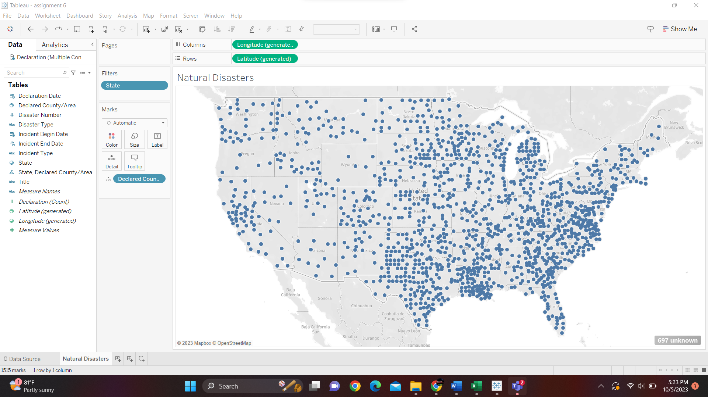

B)

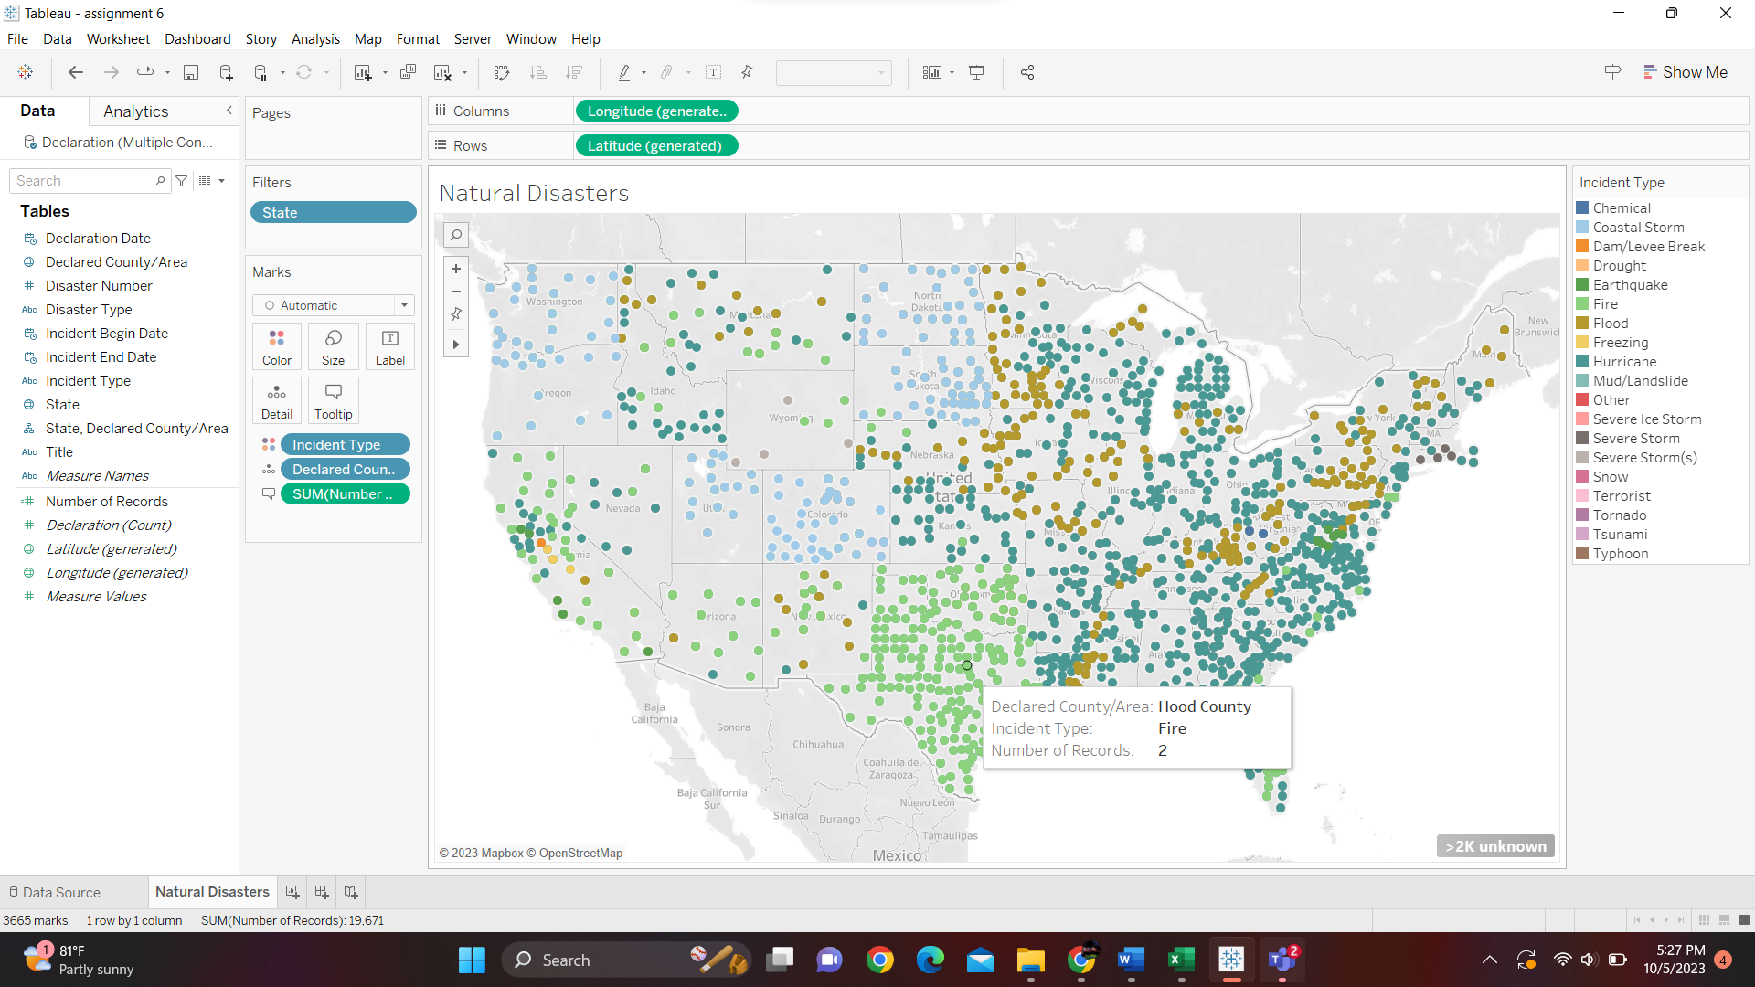

C)

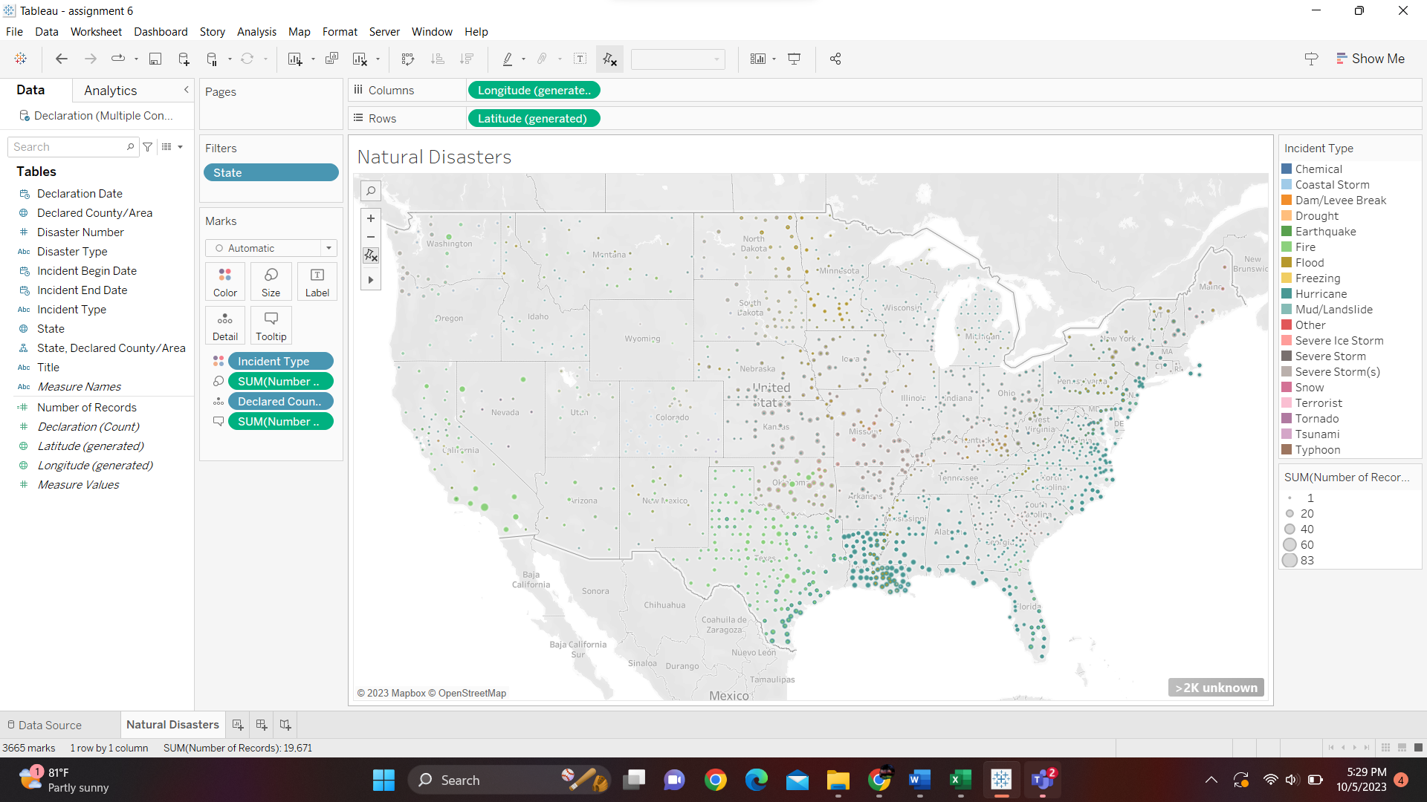

D)

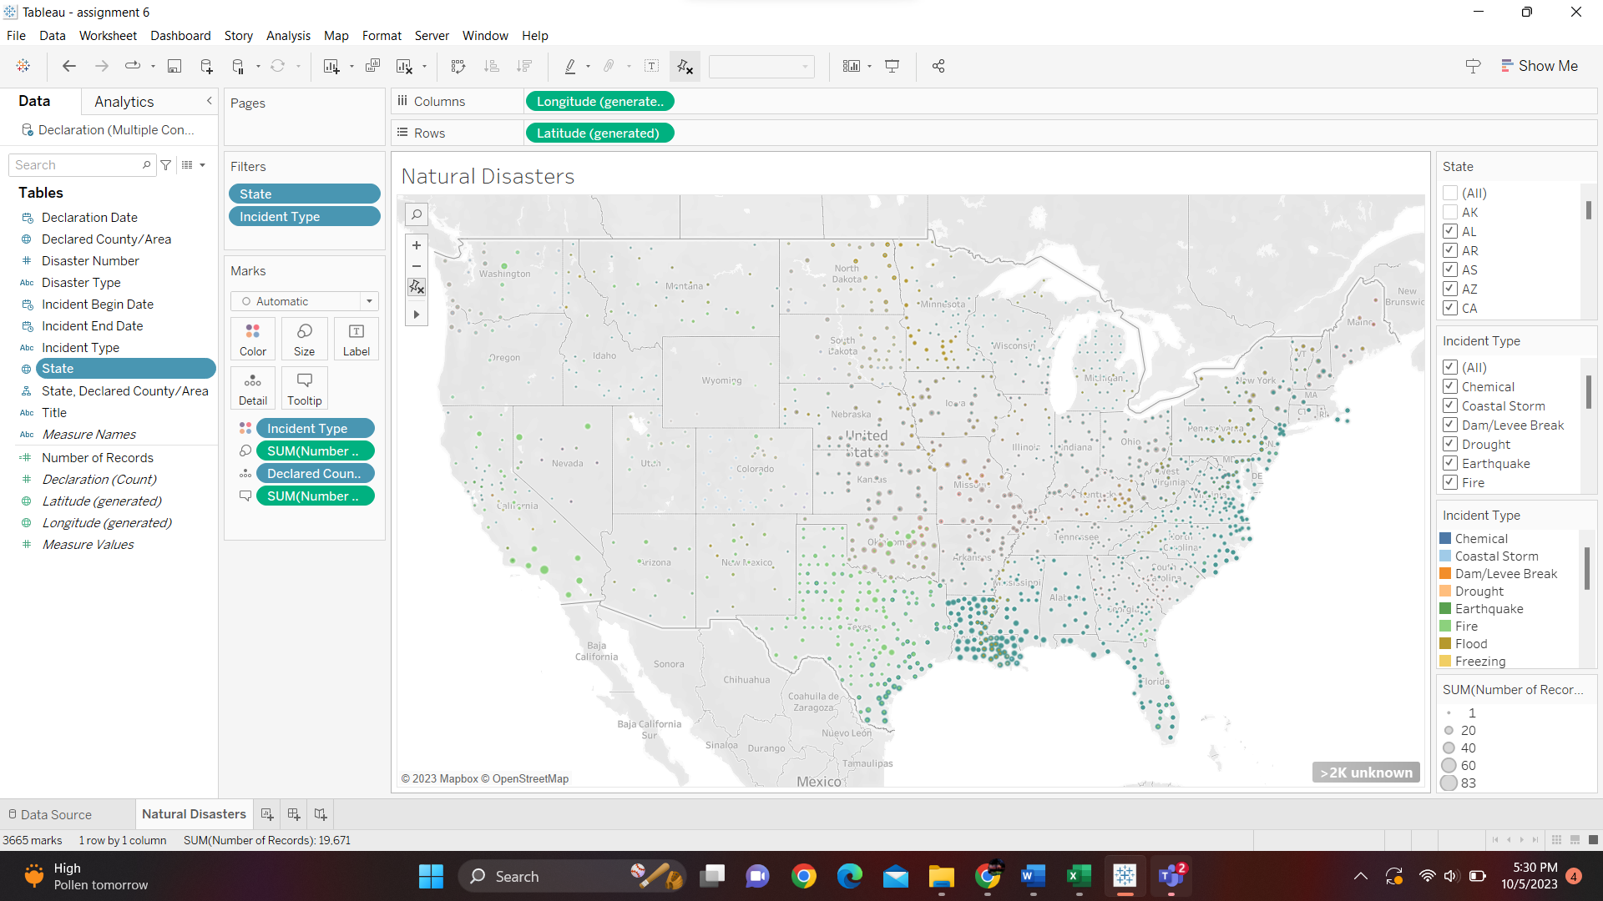

E) Texas: Fire, Alabama: Hurricane

F) Alaska and Hawaii are located on the western part of the US. In the exercise we have only concentrated on the lower 48 states of the United States.

G) c) using Colors

H) We have visually encoded the number of incidents in the county using the “Size” card by placing “Number of Records” in it.

**Part 2: Visualize all refinery locations for one ‘Energy Company’**

I)

List and Name of Refineries with county name followed by State name:

1. Exxon Mobile Refinery & Supply Co – Harris, Texas, USA
2. Exxon Mobile Refinery & Supply Co – East Baton Rouge Parish, Louisiana, USA
3. Exxon Mobile Refinery & Supply Co – Jefferson, Texas, USA
4. Exxon Mobile Refinery & Supply Co – will, Illinois, USA
5. Exxon Mobile Refinery & Supply Co – Yellowstone, Montana, USA

J)

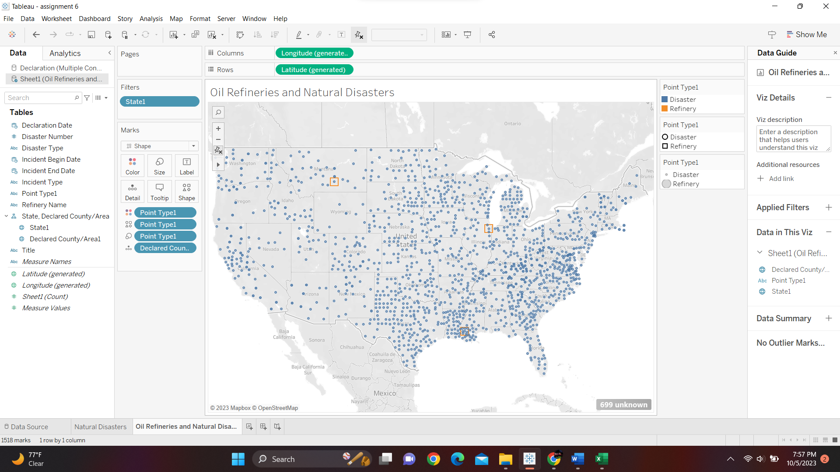

K)

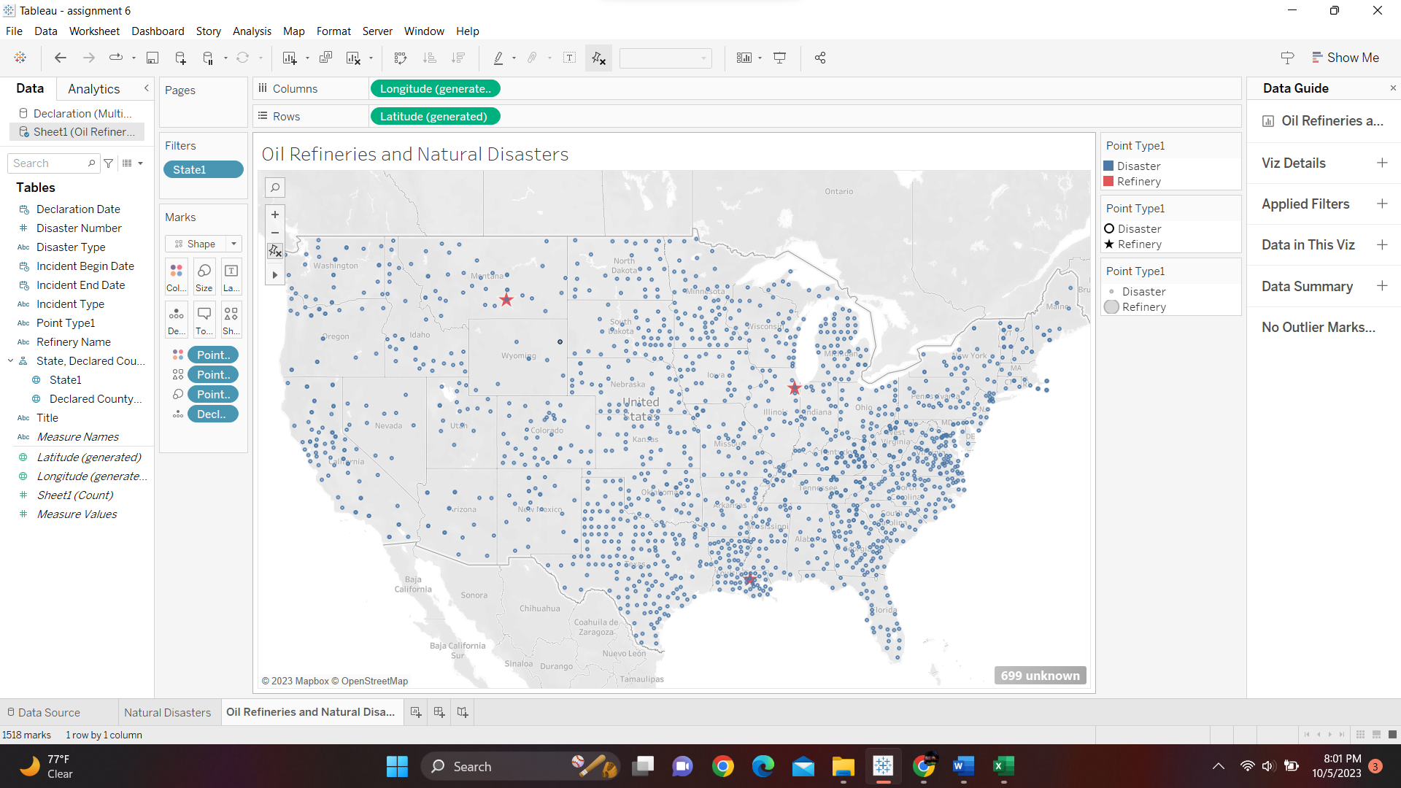

L) Illinois, Montana, Louisiana, and Texas

M)

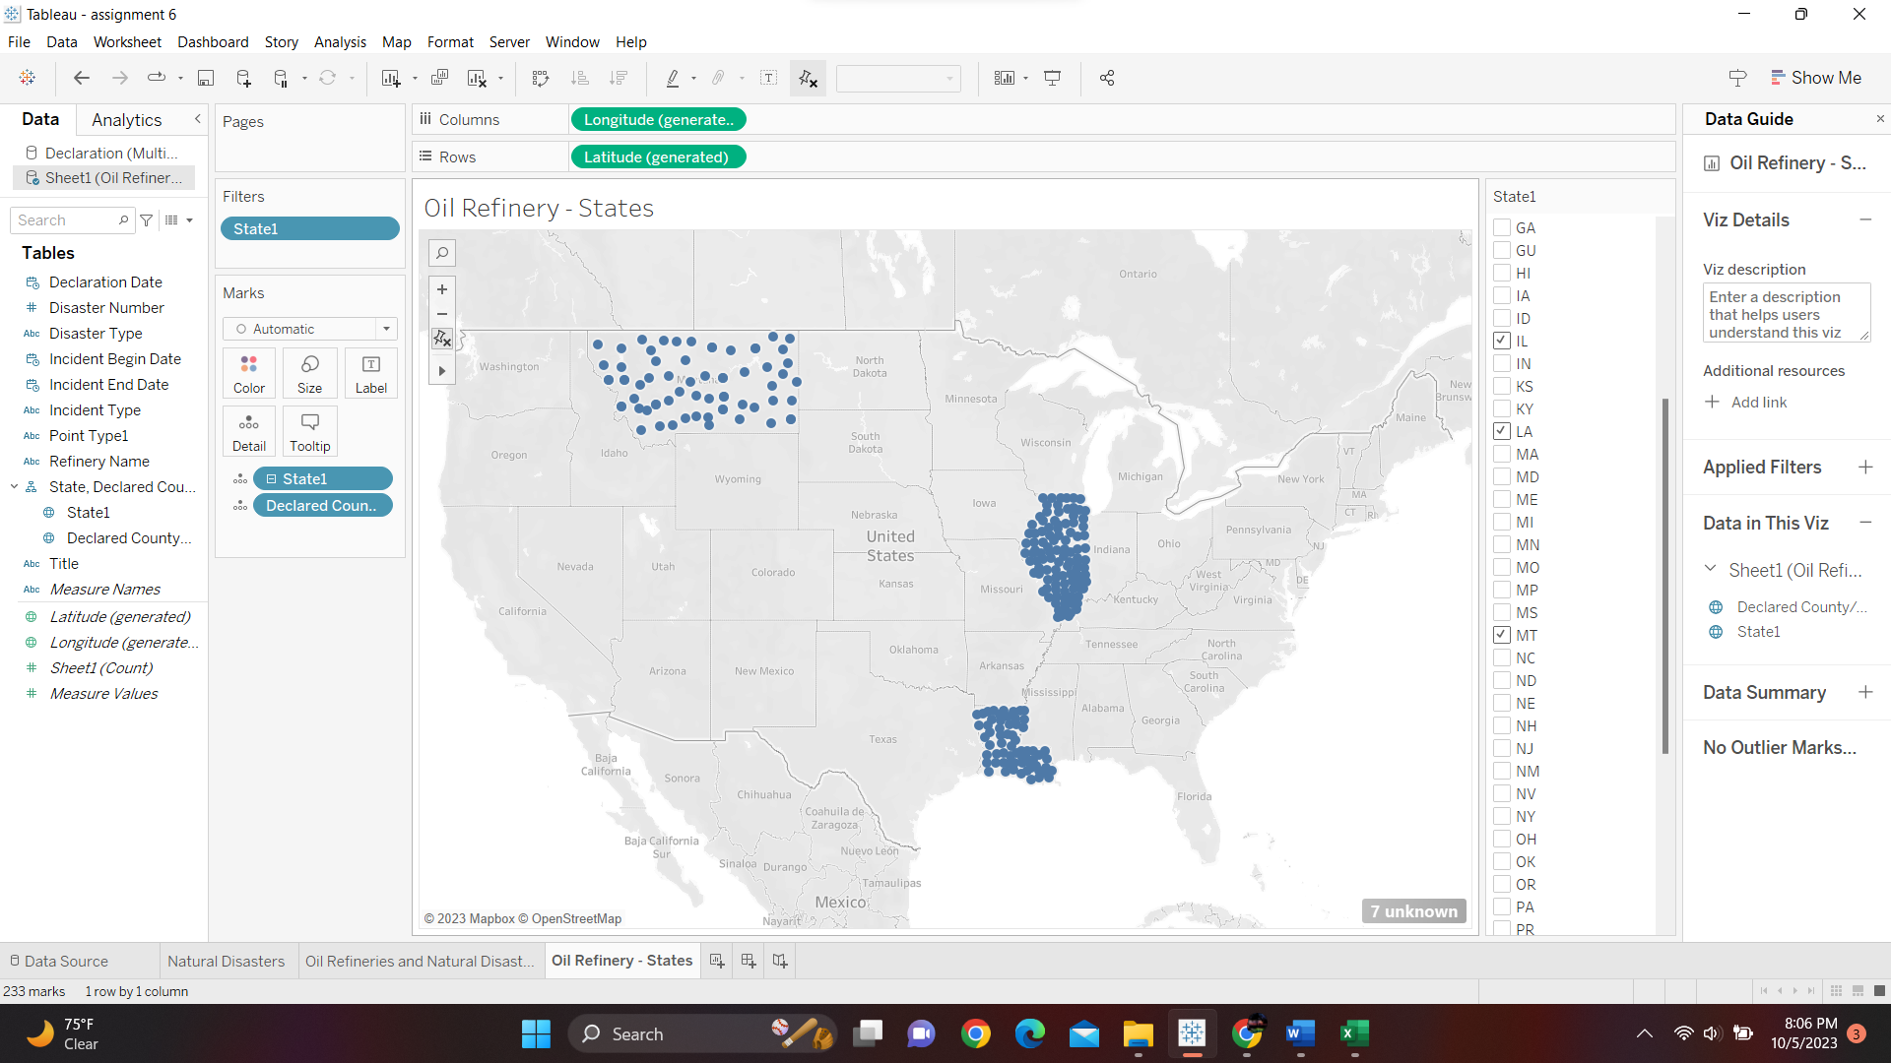

N)

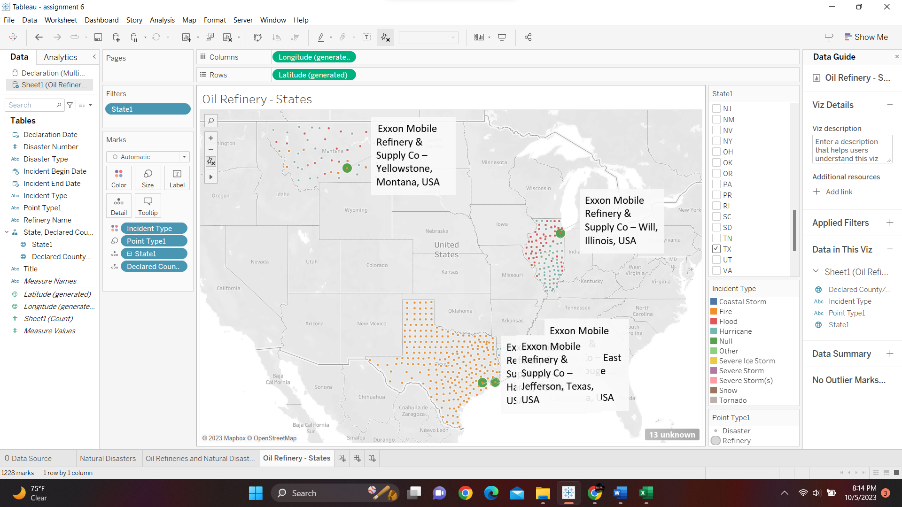

O)

Texas: Fire

Louisiana: Flood, Hurricane

P)

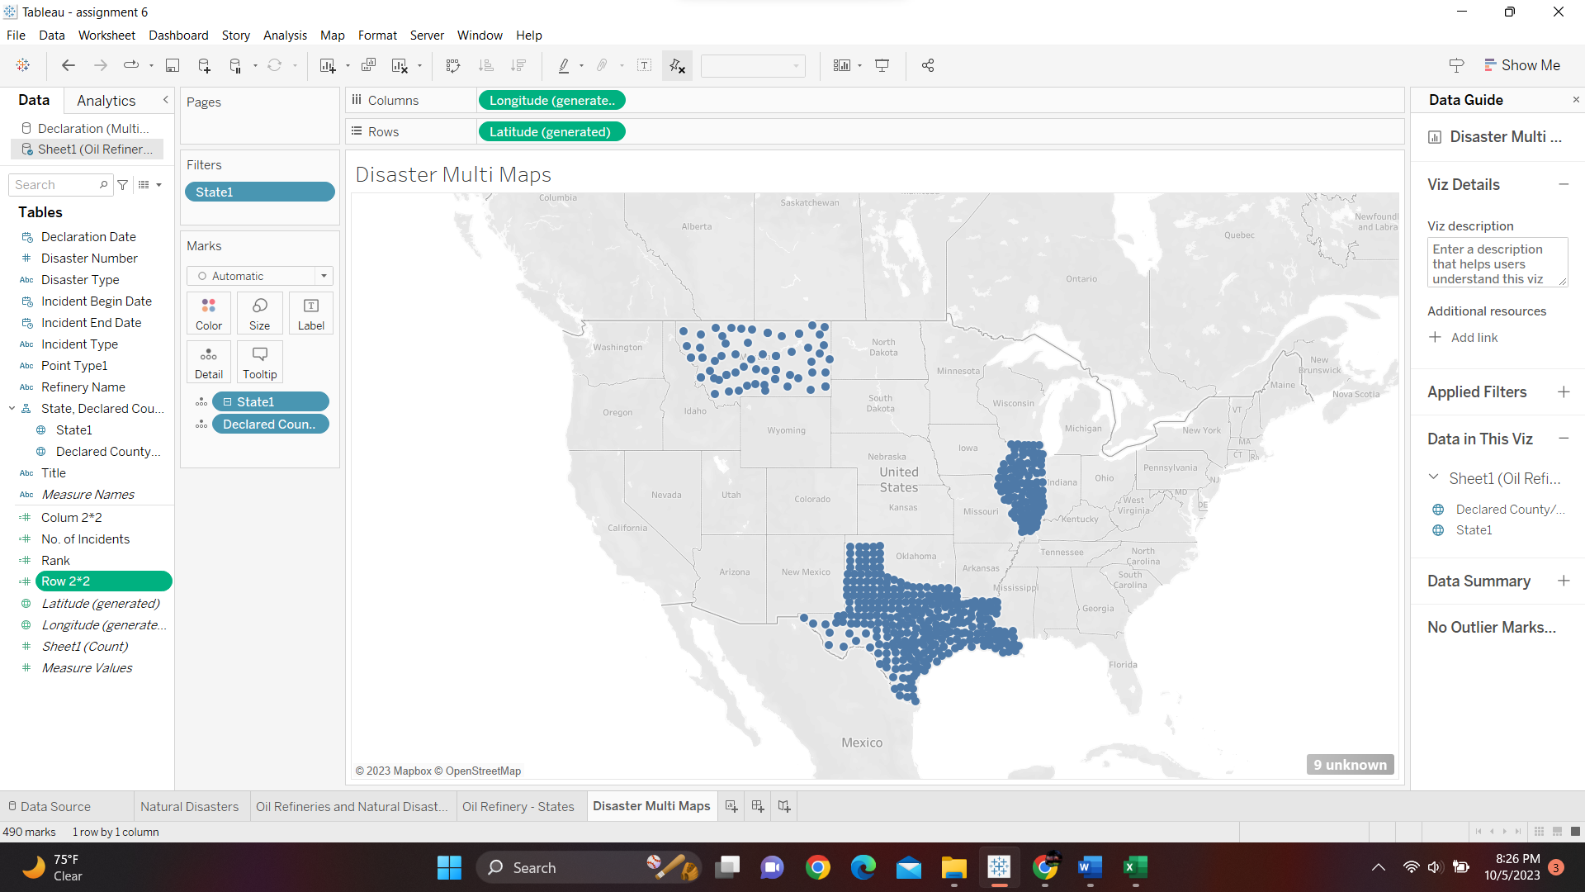

Q) Severe Storms(s)

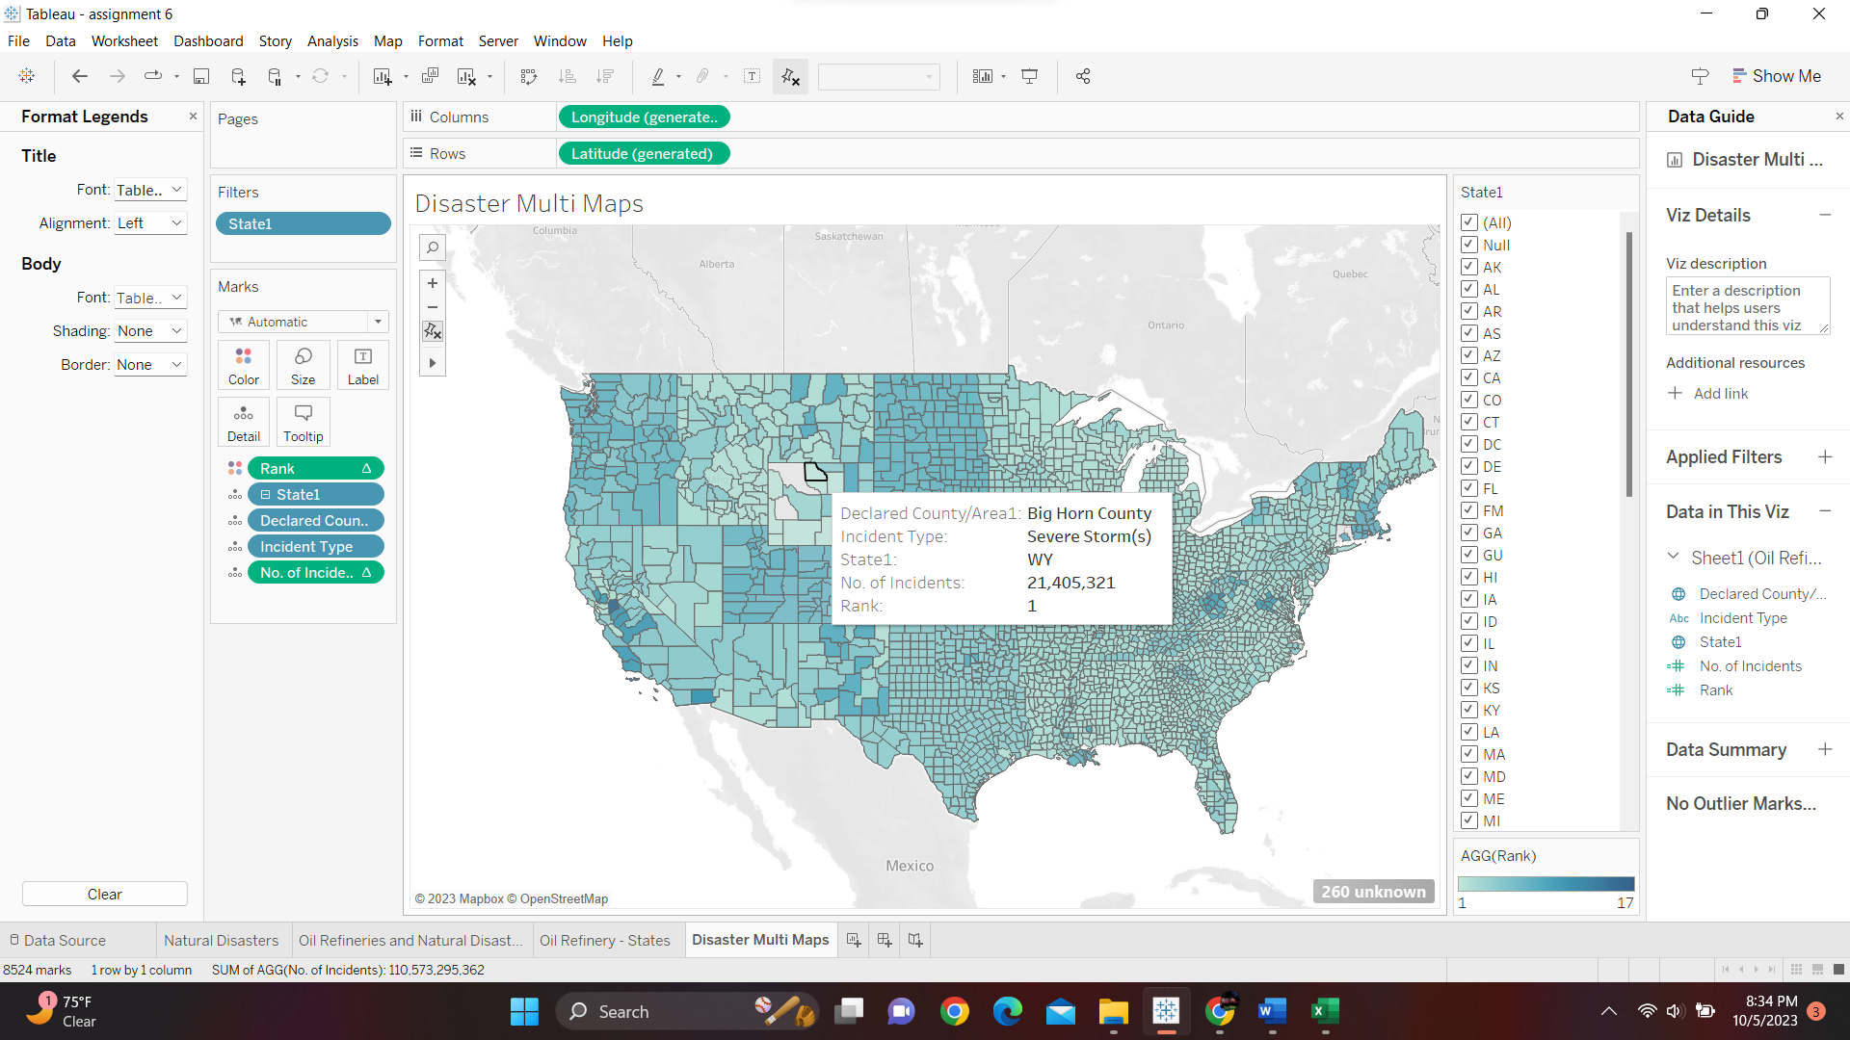

R)

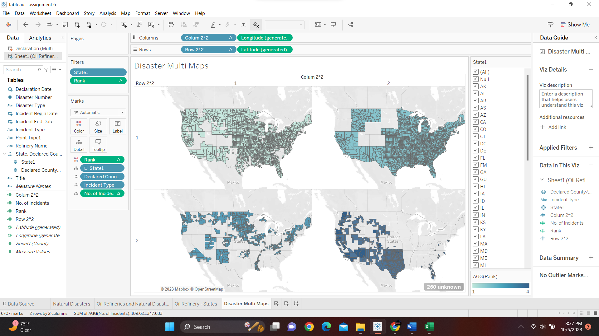

S)

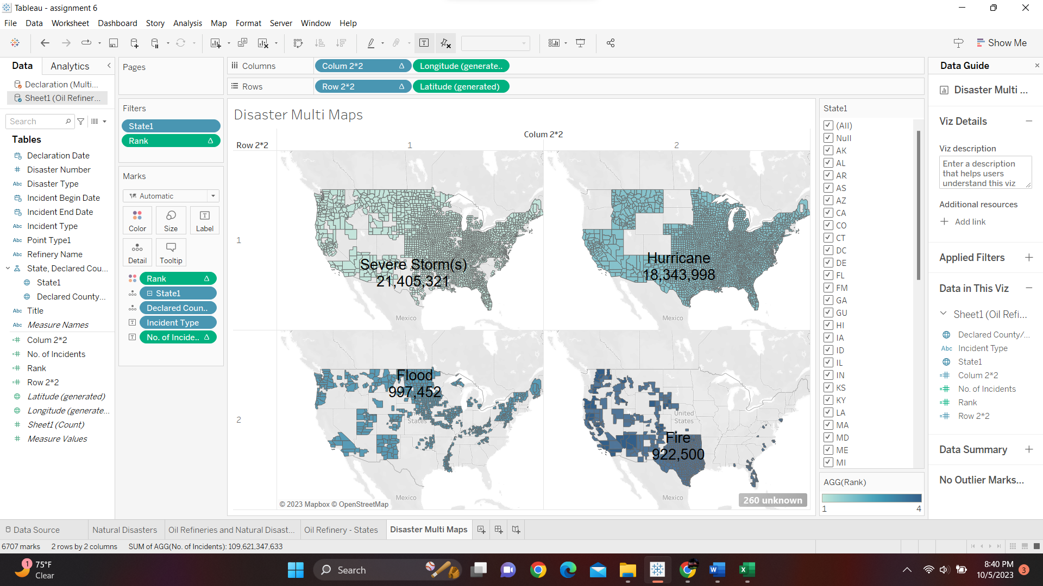

T) The calculated fields got added to Measure pane and not to dimension pane because they are immeasurable values.

U)

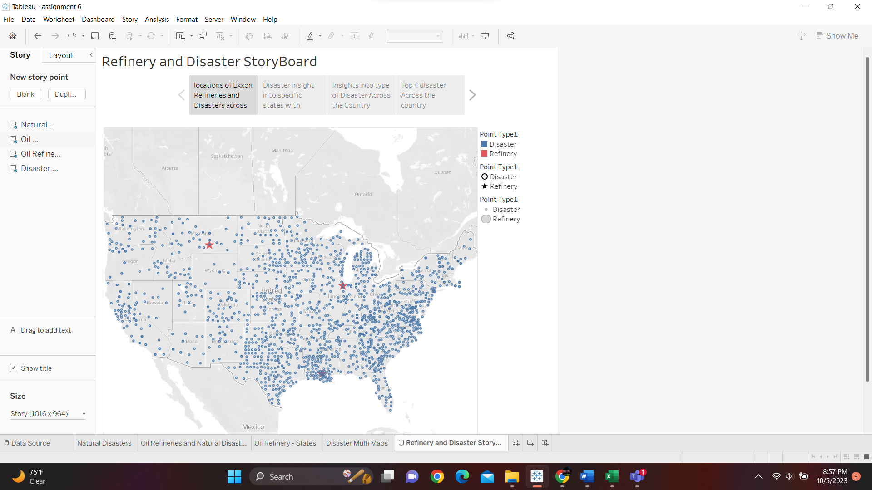

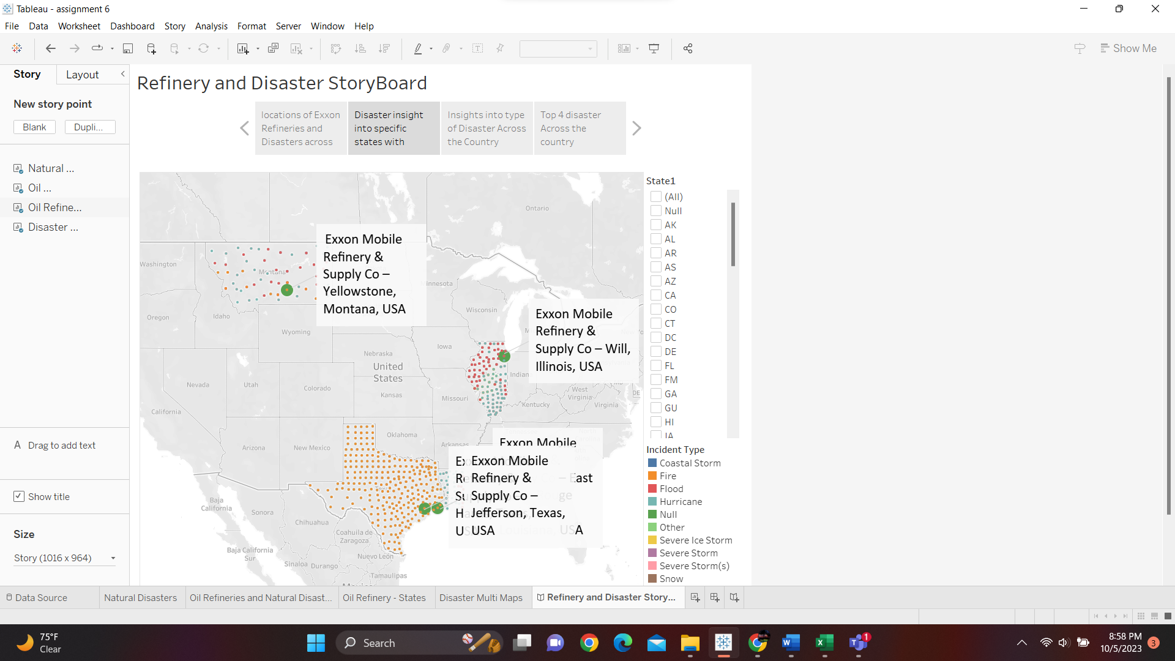

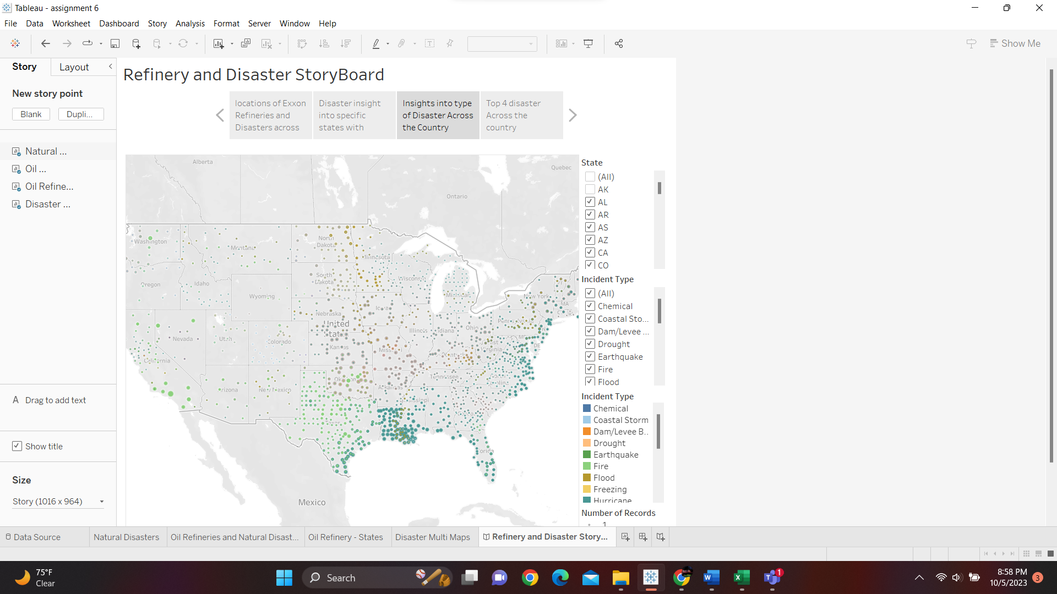

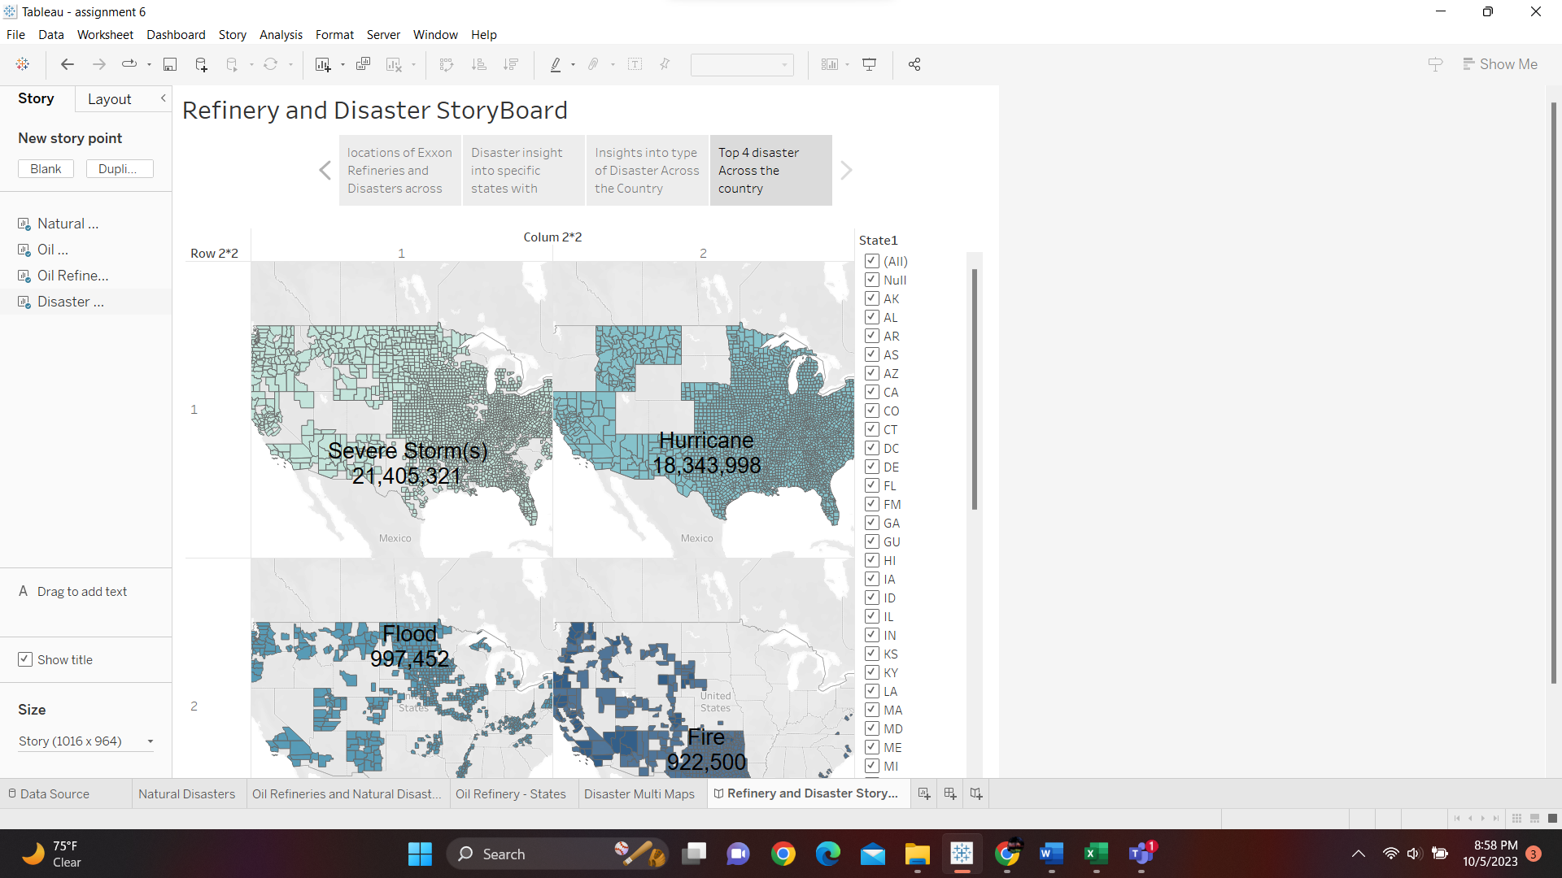

V) Logos was used, I started out with mapping points of all disaster and refineries of Exxon on map, then looked at the type of disasters in those specific states where Exxon has refineries. Then broadened the view and looked at the different types of disasters across the country and then finally mapped the top 4 disasters in multi map.